**Experiment No. 02**

**Object:** To connect 2 Pc’s with cross-over cable

(Introduction to Cisco Packet Tracer)

**Date:** February 10, 2018

# Figures:

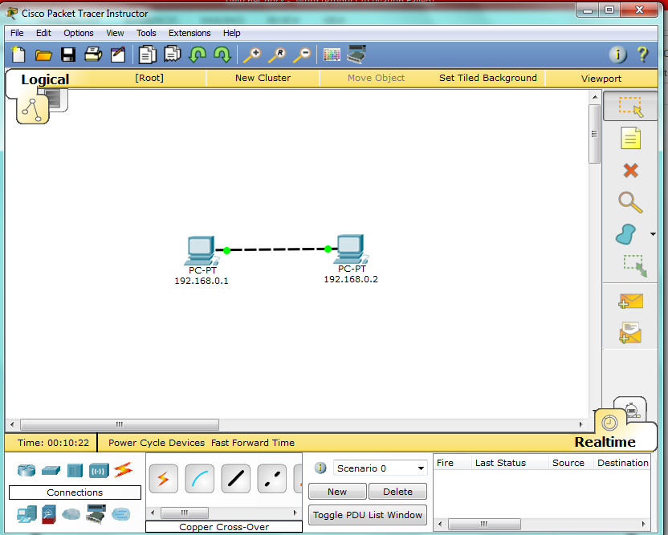

# Configurations:

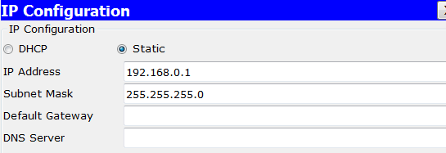

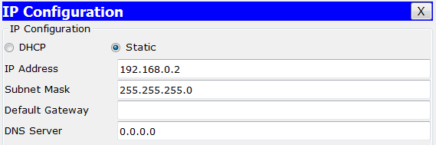

# Ping Test:

